

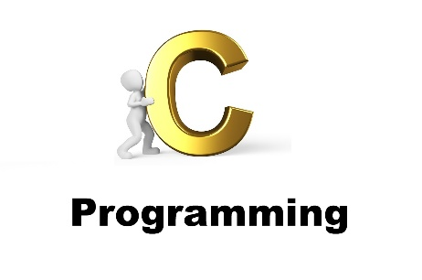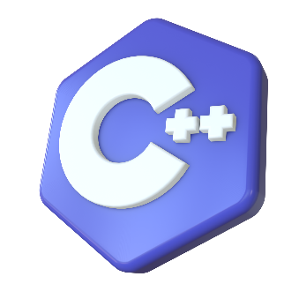

~ Abhishek Adhikari

**2024**

**About**

This project is completed as part of Task 3 for Computer Programming, covering the completion of various C programming tasks.

Submitted to:

Shrawan Thakur

Project Documentation: C Programming Exercises 3

1. Introduction 3

2. Programs 3

2.1 Check if a Number is Even or Odd 3

Explanation: 3

Code: 3

Output: 4

2.2 Check if a Number is Positive or Negative 4

Explanation: 4

Code: 4

Output: 5

2.3 Check if a Year is a Leap Year 5

Explanation: 5

Code: 5

Output: 6

2.4 Check Voting Eligibility Based on Age 6

Explanation: 6

Code: 6

Output: 7

2.5 Determine Value of `n ` Based on ` m ` 7

Explanation: 7

Code: 7

Output: 8

2.6 Categorize a Person's Height 8

Explanation: 8

Code: 8

Output: 9

2.7 Find the Largest of Three Numbers 9

Explanation: 9

Code: 9

Output: 10

2.8 Calculate the Root of a Quadratic Equation 10

Explanation: 10

Code: 10

Output: 11

2.9 Calculate Total, Percentage, and Division 11

Explanation: 11

Code: 11

Output: 12

2.10 Temperature Categorization 12

Explanation: 12

Code: 12

Output: 13

2.11 Check Triangle Type 13

Code: 13

Output: 14

2.12 Check if a Triangle Can be Formed 14

Code: 14

Output: 15

2.13 Check if a Character is an Alphabet, Digit, or Special Character 15

Code: 15

Output: 16

2.14 Check if an Alphabet is a Vowel or Consonant 16

Code: 16

Output: 17

2.15 Check Character Type (Uppercase, Lowercase, Digit, Special Symbol) 17

Code: 17

Output: 18

3. Conclusion 18

4. References 18

# Project Documentation: C Programming Exercises

## Introduction

This document provides a comprehensive overview of various C programming exercises. Each section includes the purpose of the program, the code, and instructions for compiling and running the program.

## Programs

### 2.1 Check if a Number is Even or Odd

#### Explanation:

* The program prompts the user to enter an integer.
* It checks if the number is even by using the modulo operator %.
* If the number is divisible by 2, it is even; otherwise, it is odd.

#### Code:

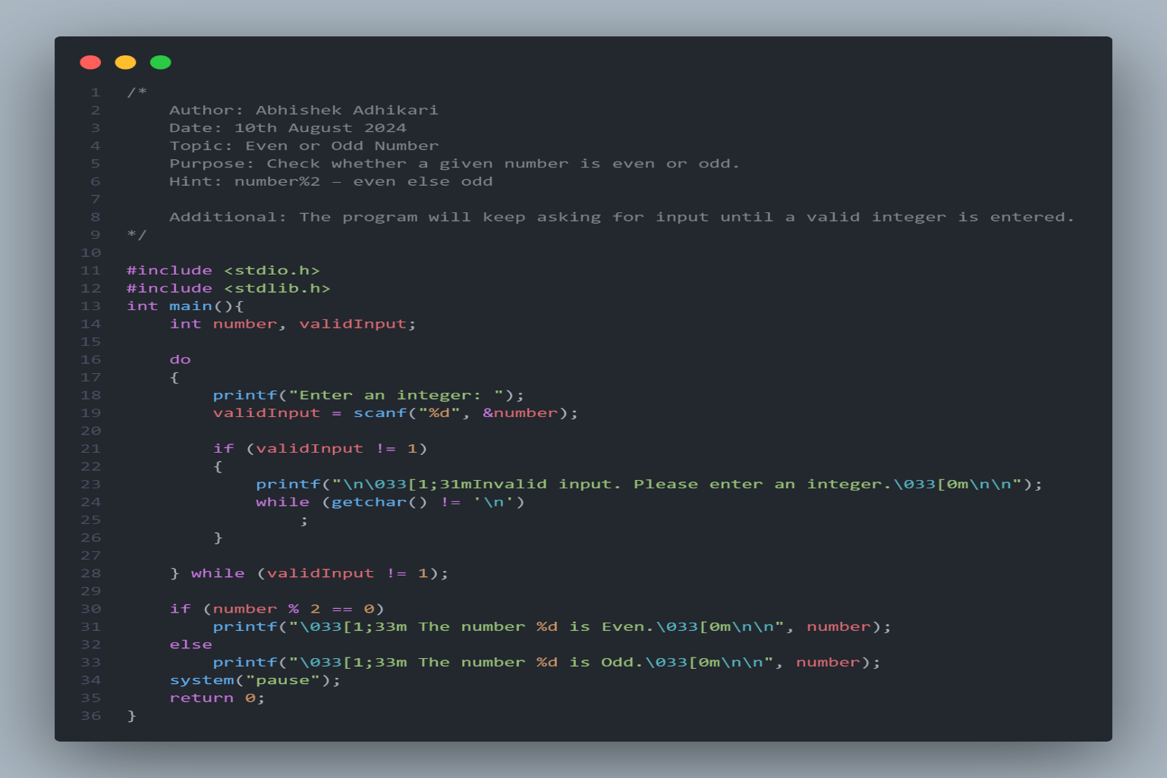

#### Output:

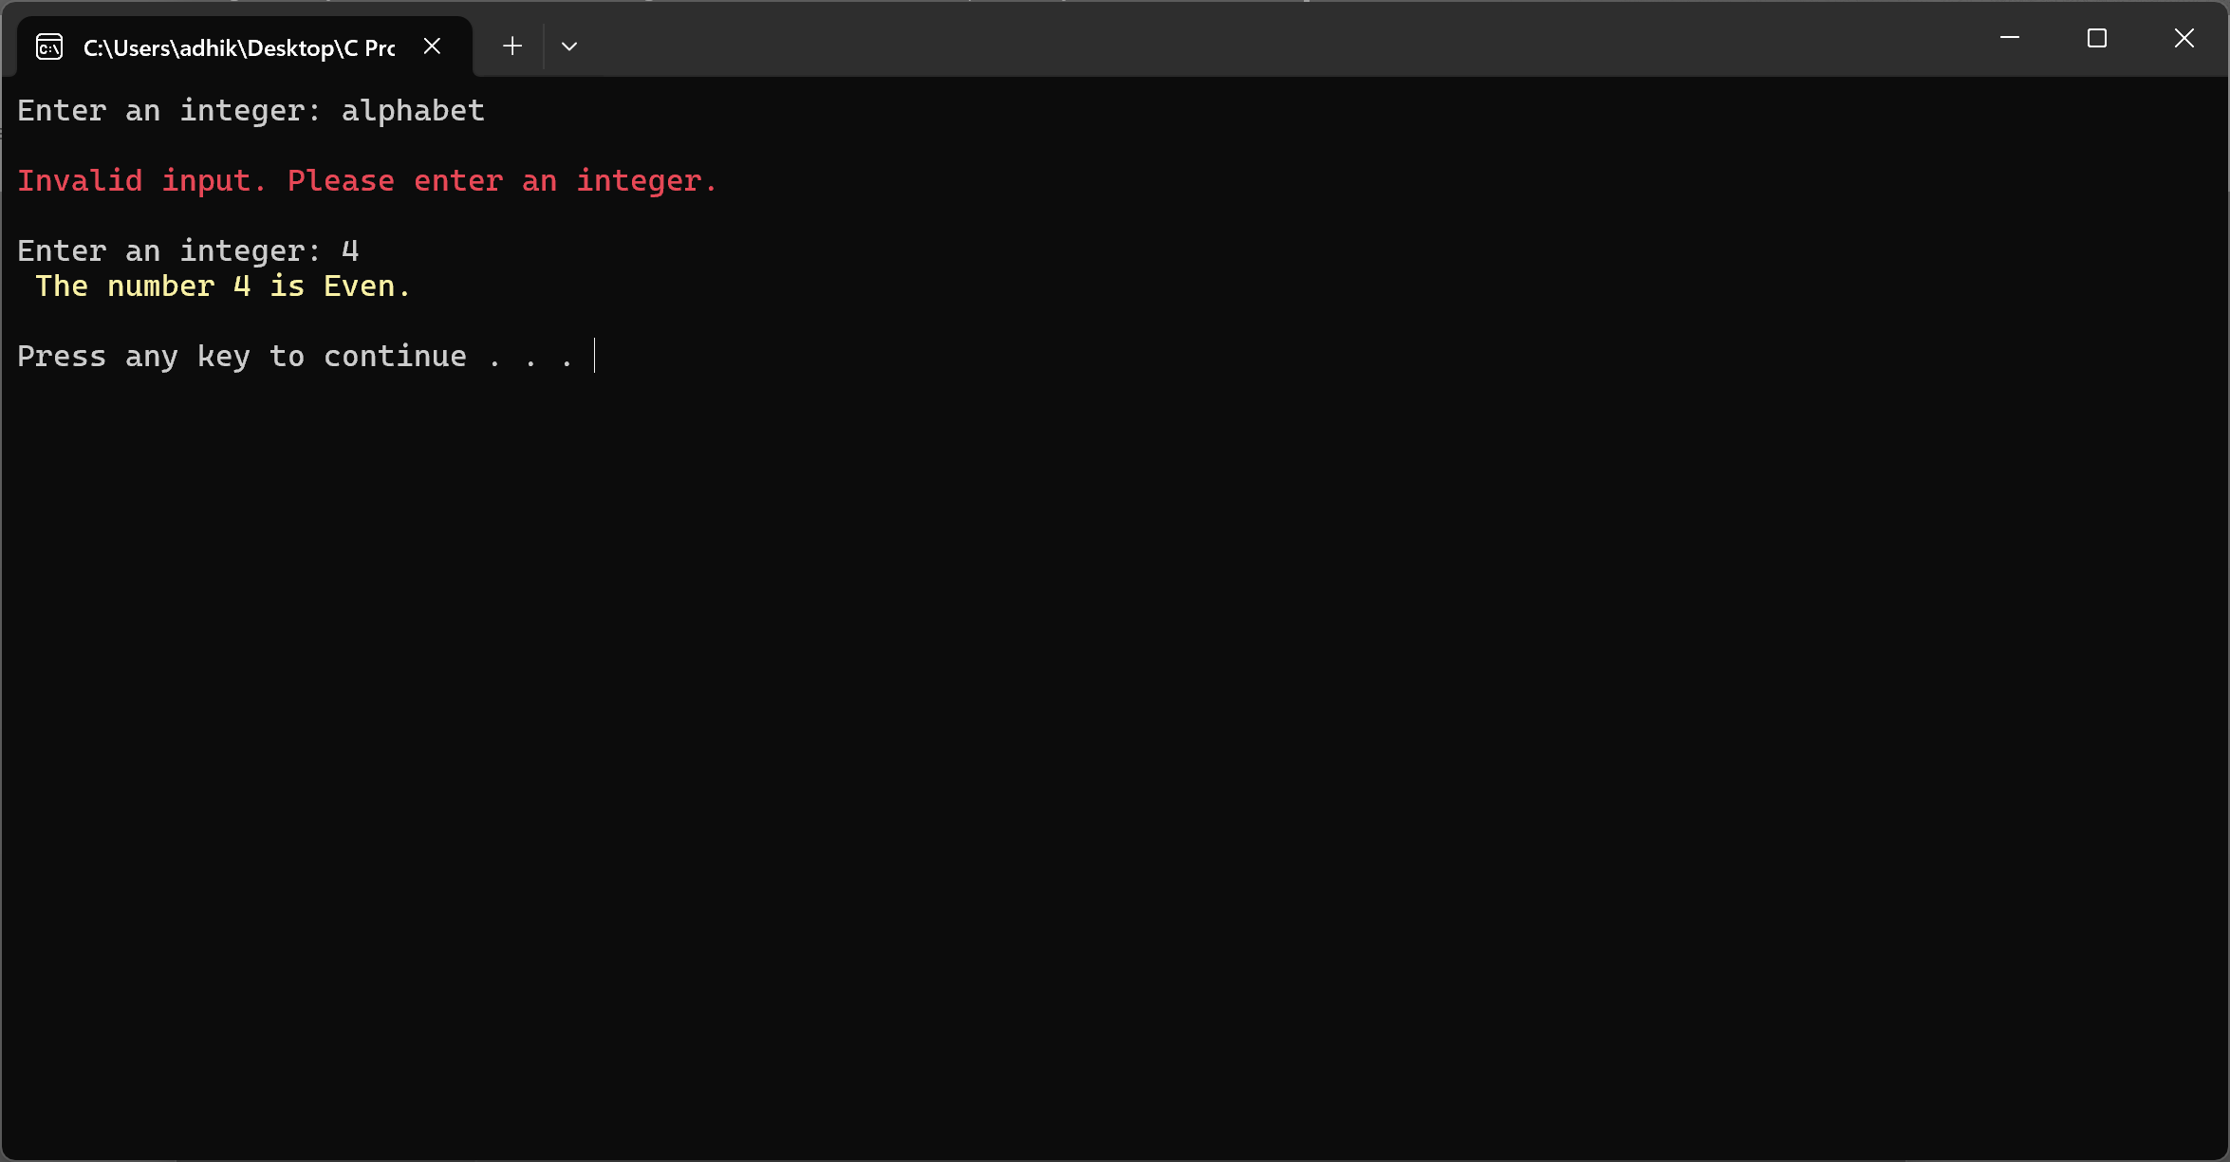

### 2.2 Check if a Number is Positive or Negative

#### Explanation:

* The program checks if the number entered is positive, negative, or zero.

#### Code:

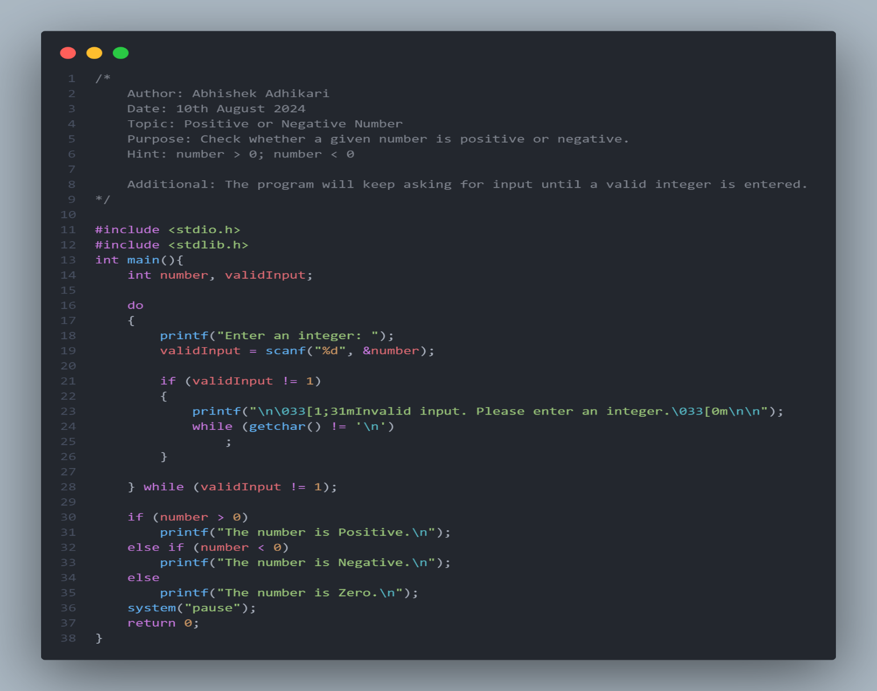

#### Output:

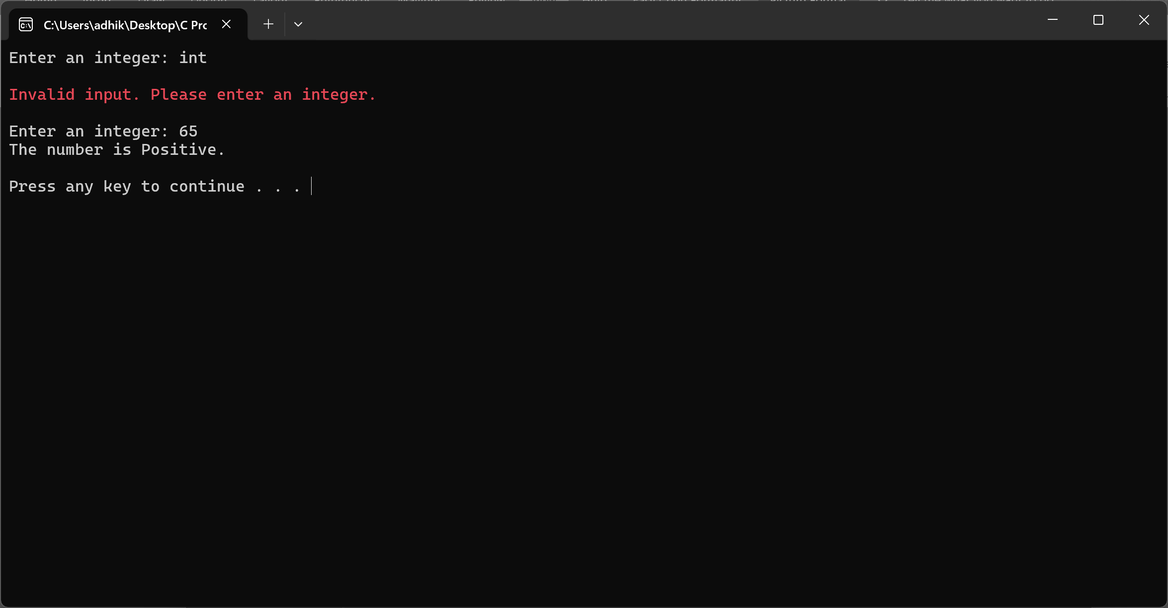

### 2.3 Check if a Year is a Leap Year

#### Explanation:

* The program determines if a year is a leap year using conditional checks.

#### Code:

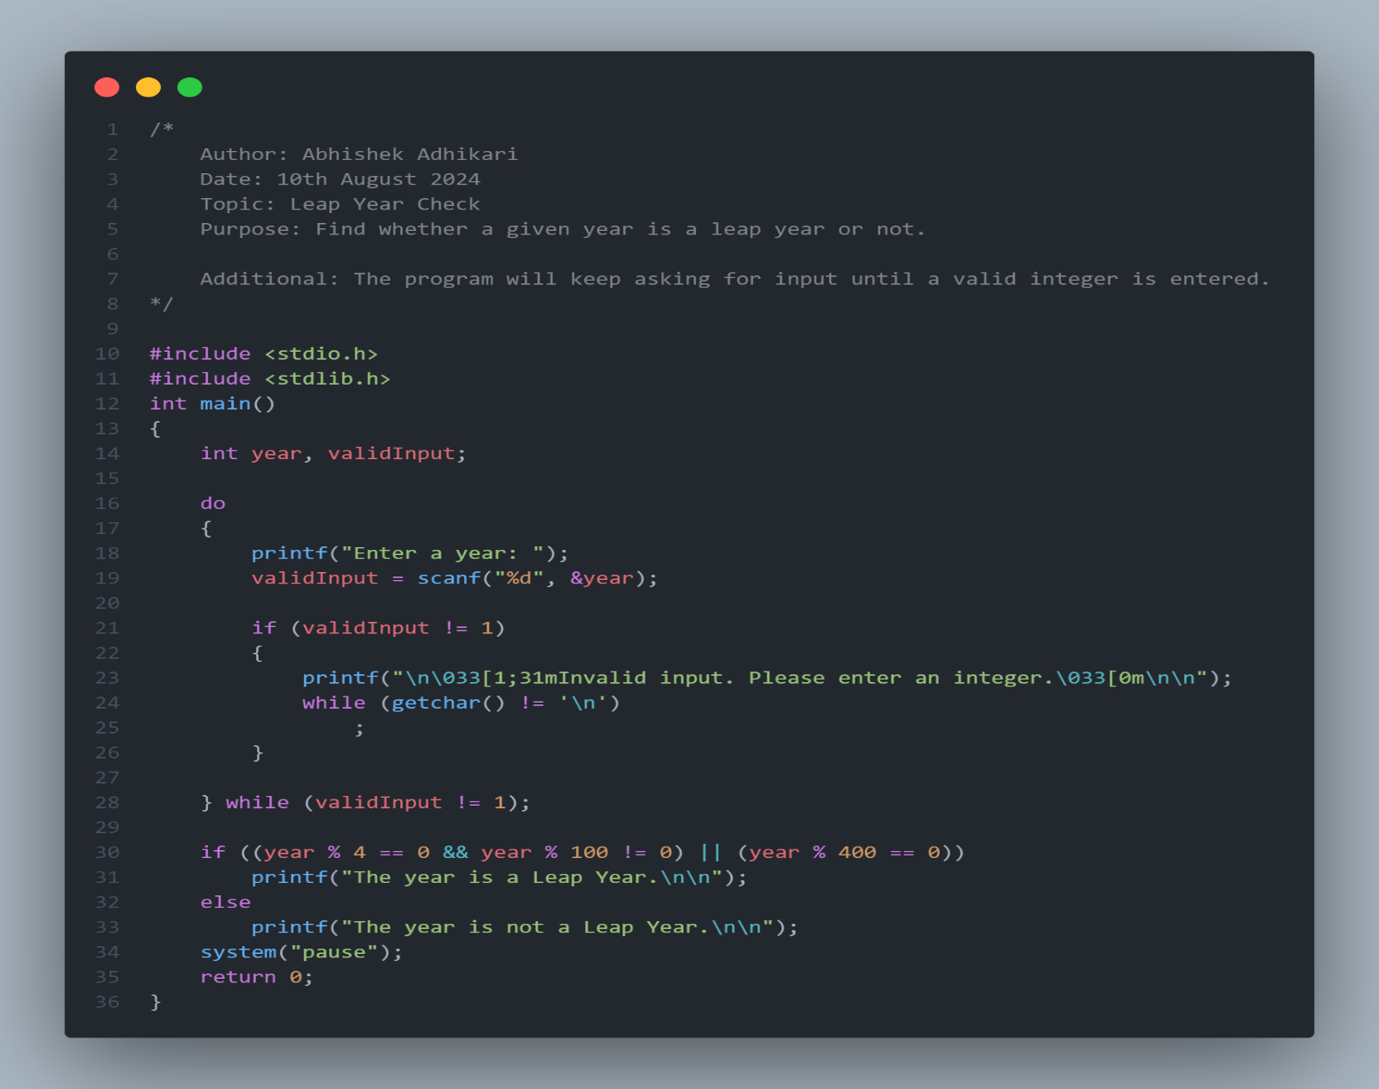

#### Output:

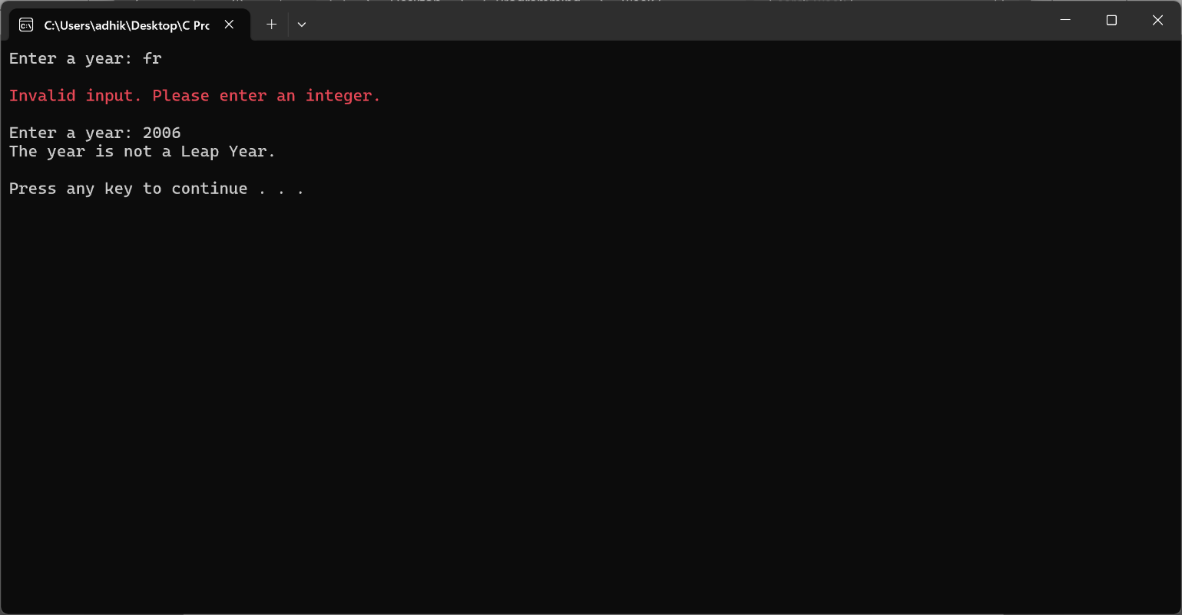

### 2.4 Check Voting Eligibility Based on Age

#### Explanation:

* The program checks if the user's age is 18 or above to determine voting eligibility.

#### Code:

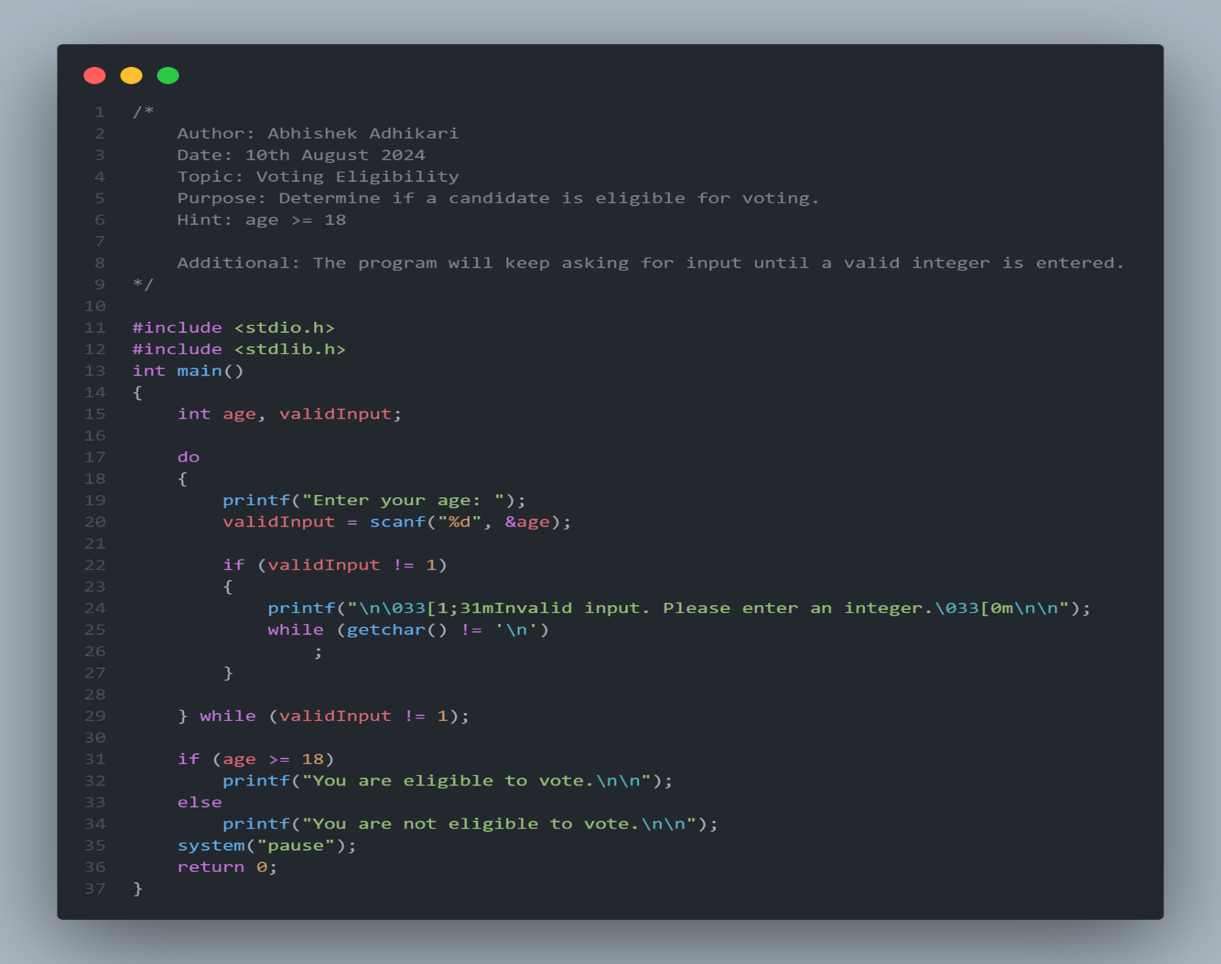

#### Output:

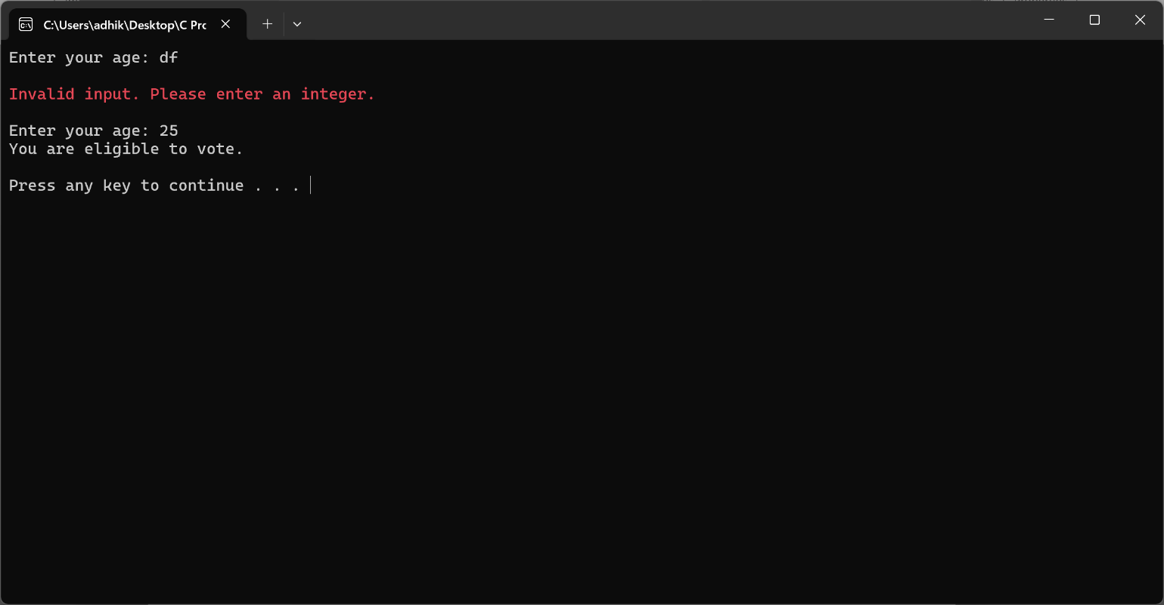

### 2.5 Determine Value of ` n ` Based on ` m `

#### Explanation:

* The program evaluates the value of ` m ` and sets ` n ` based on the given conditions.

#### Code:

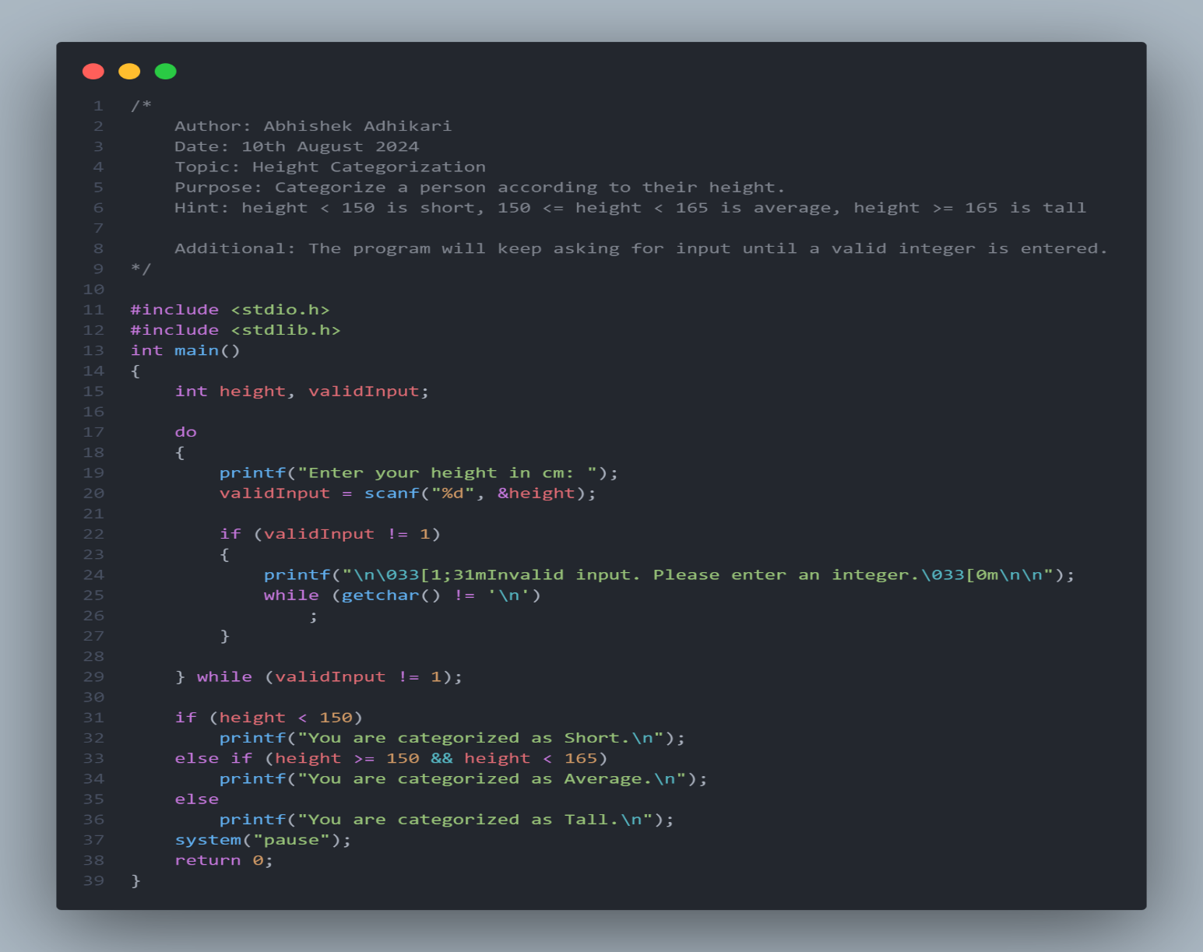

#### Output:

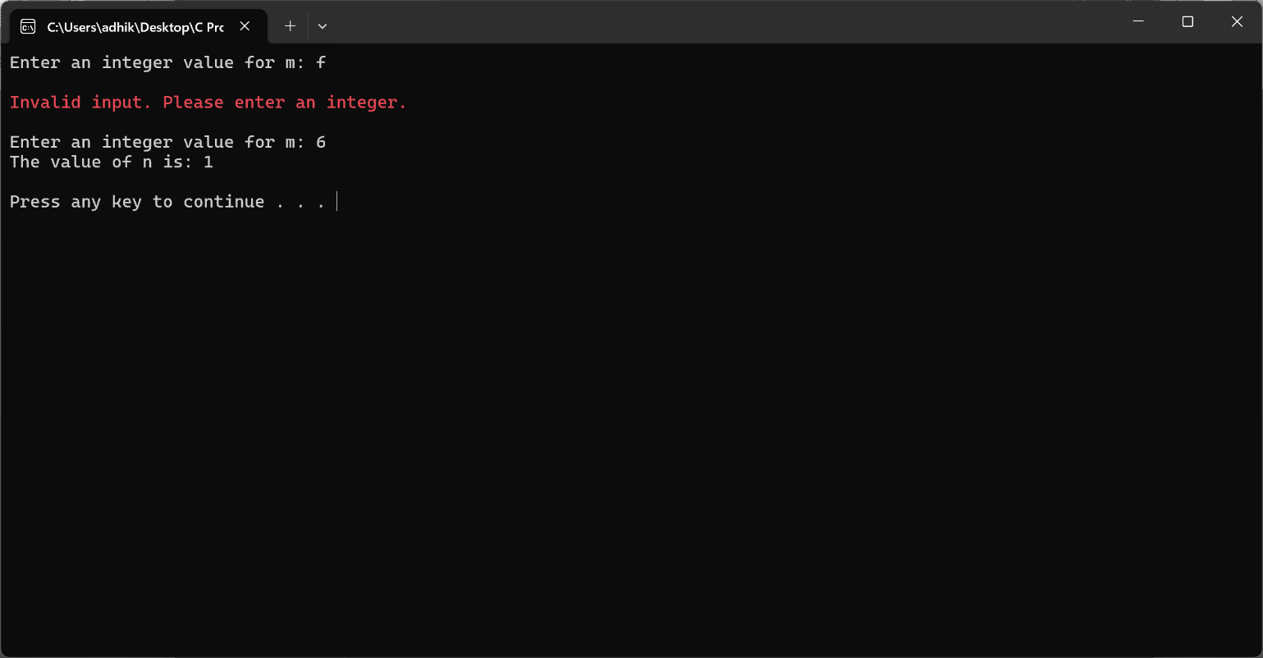

### 2.6 Categorize a Person's Height

#### Explanation:

* The program categorizes the height of a person into "Short", "Average", or "Tall".

#### Code:

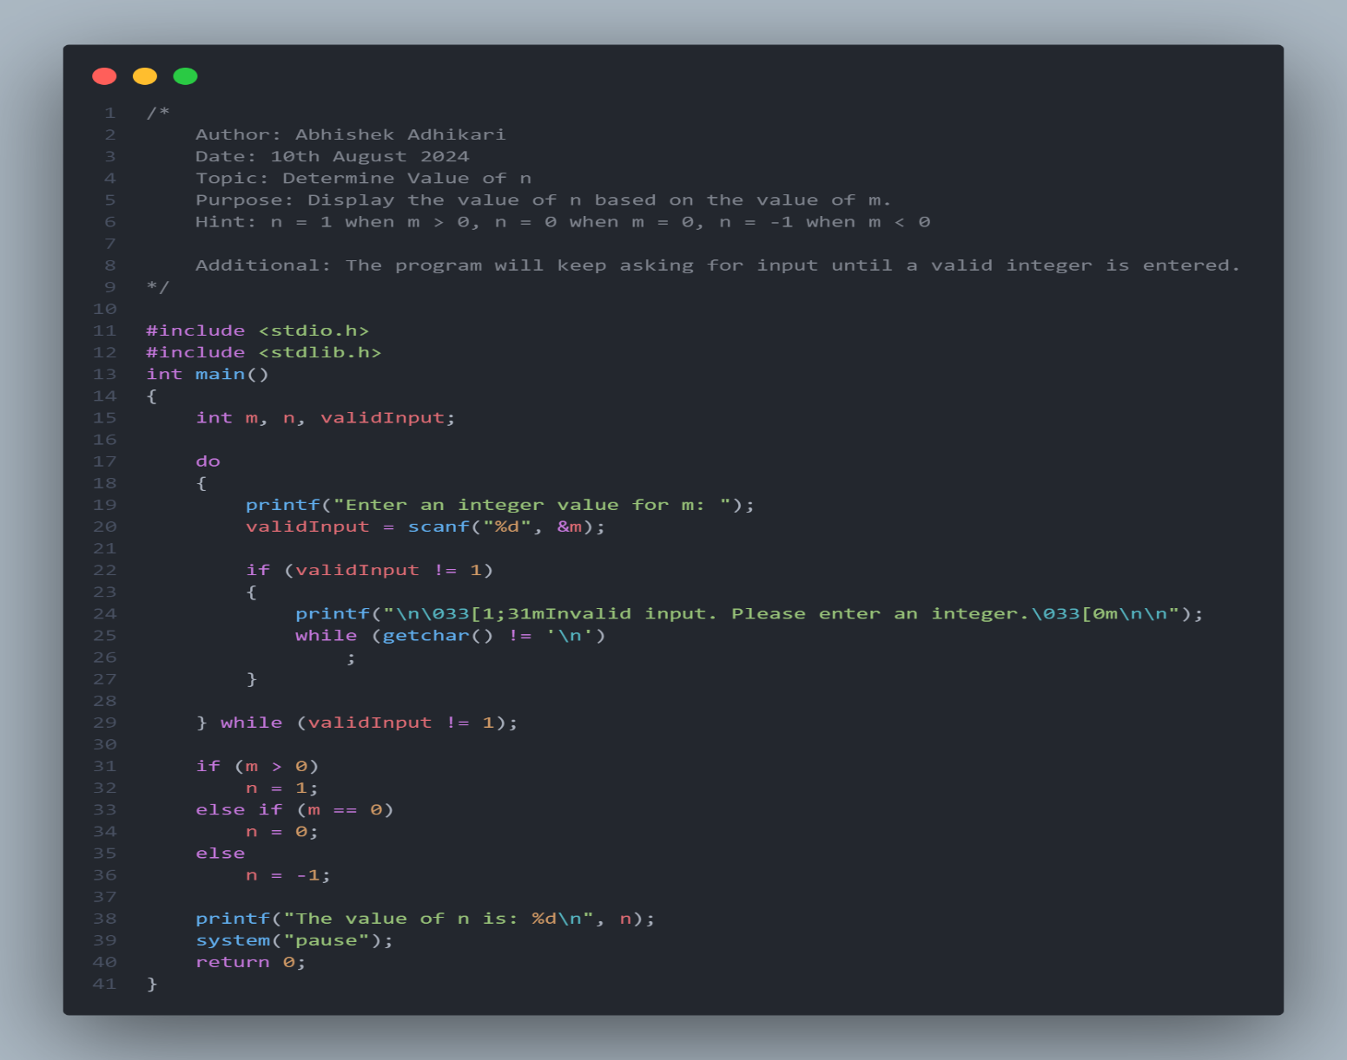

#### Output:

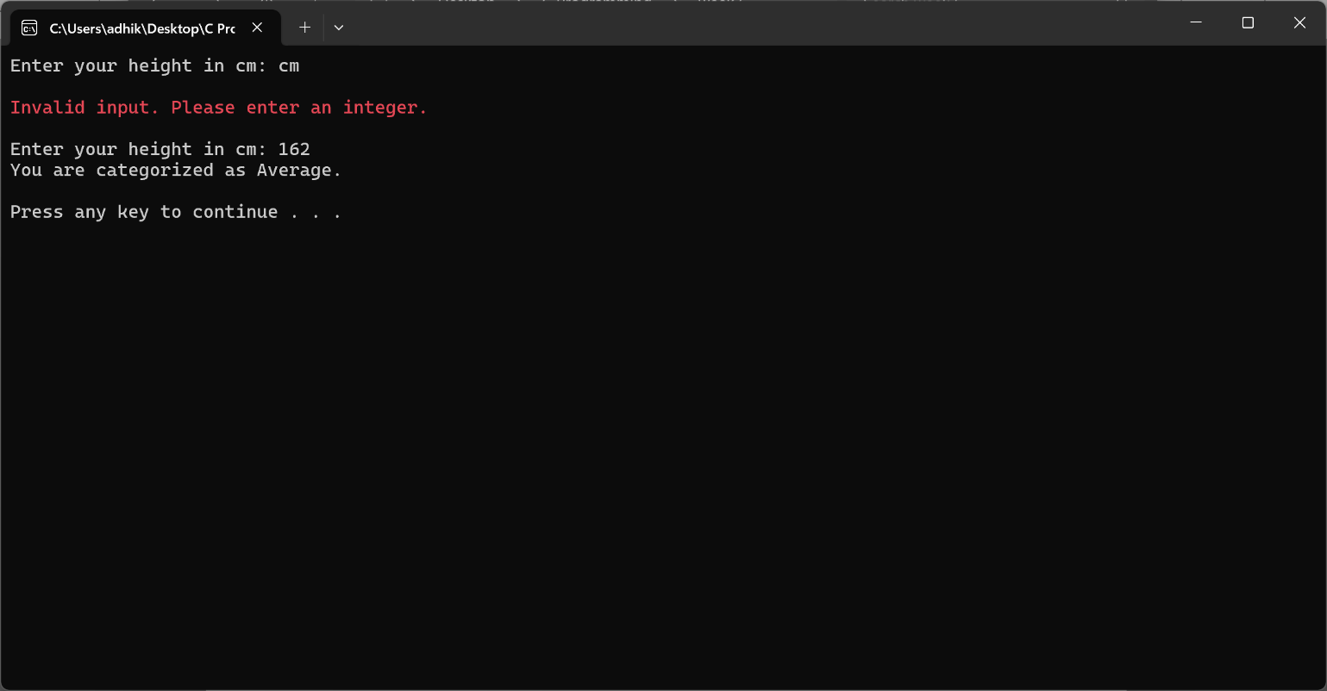

### 2.7 Find the Largest of Three Numbers

#### Explanation:

* The program determines the largest of the three input numbers.

#### Code:

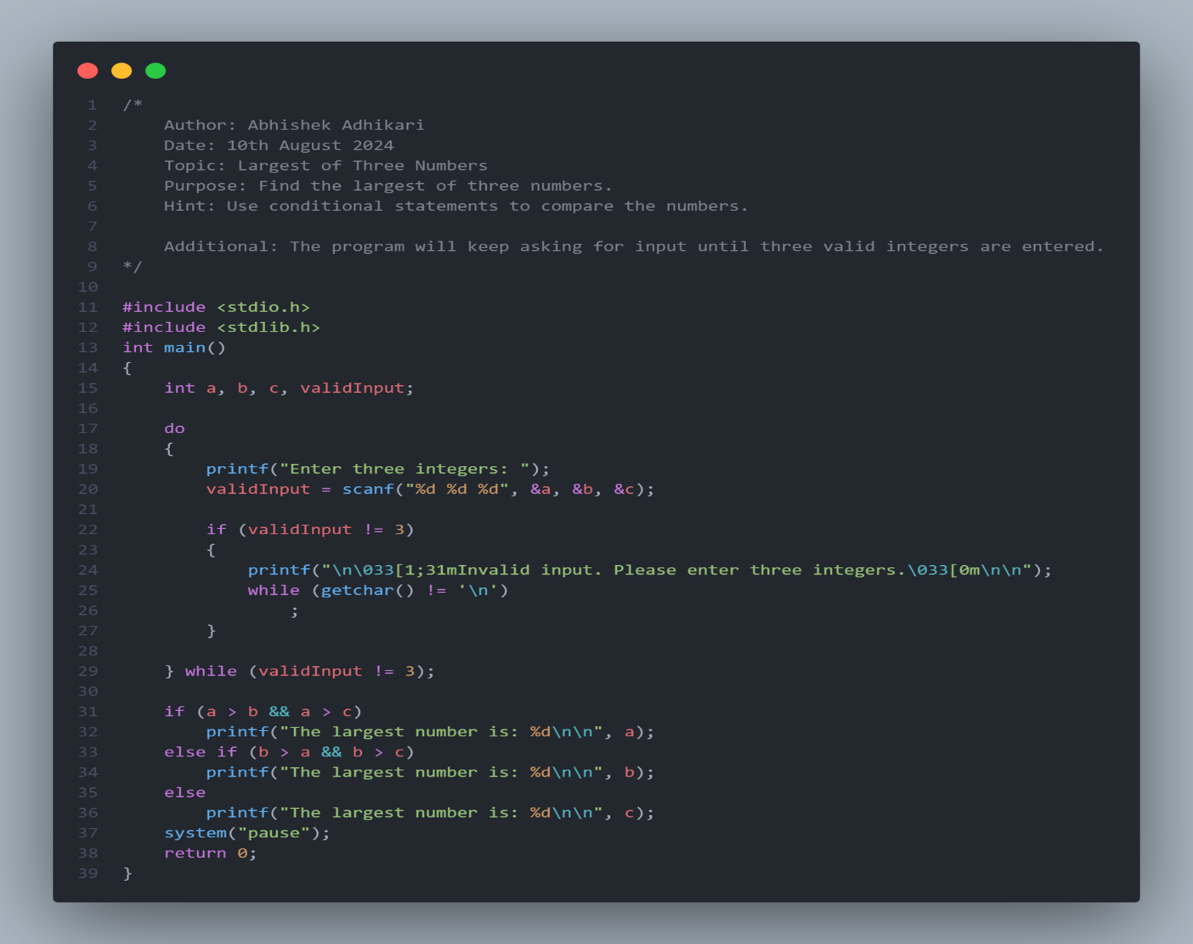

#### Output:

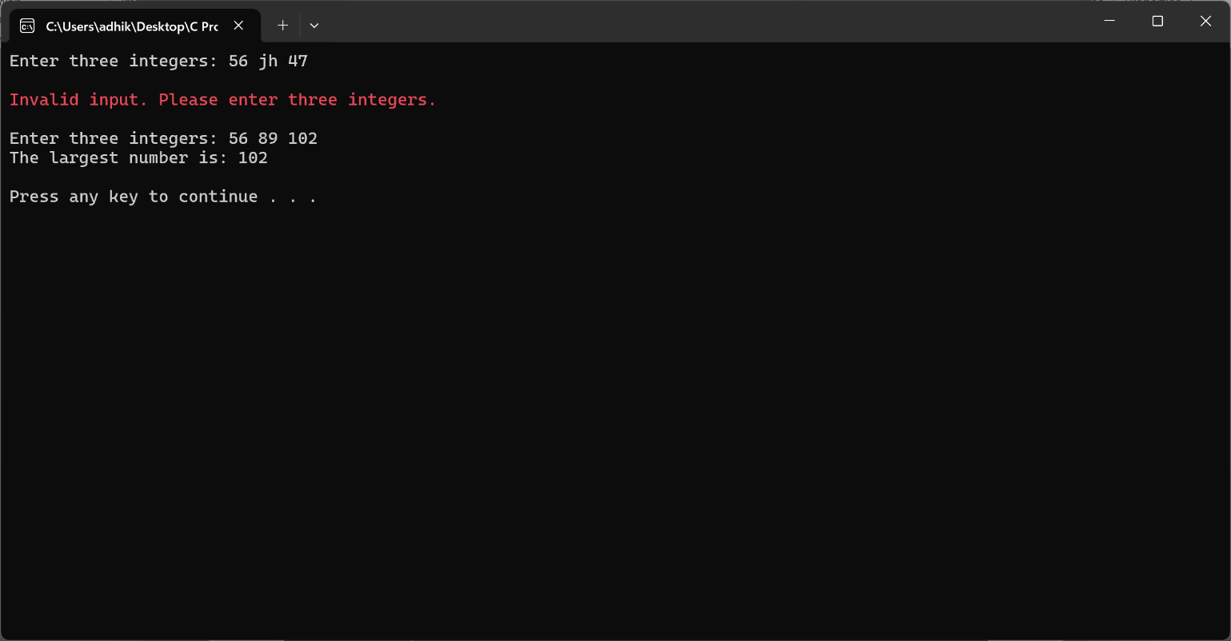

### 2.8 Calculate the Root of a Quadratic Equation

#### Explanation:

* The program computes the roots of a quadratic equation based on the discriminant value.

#### Code:

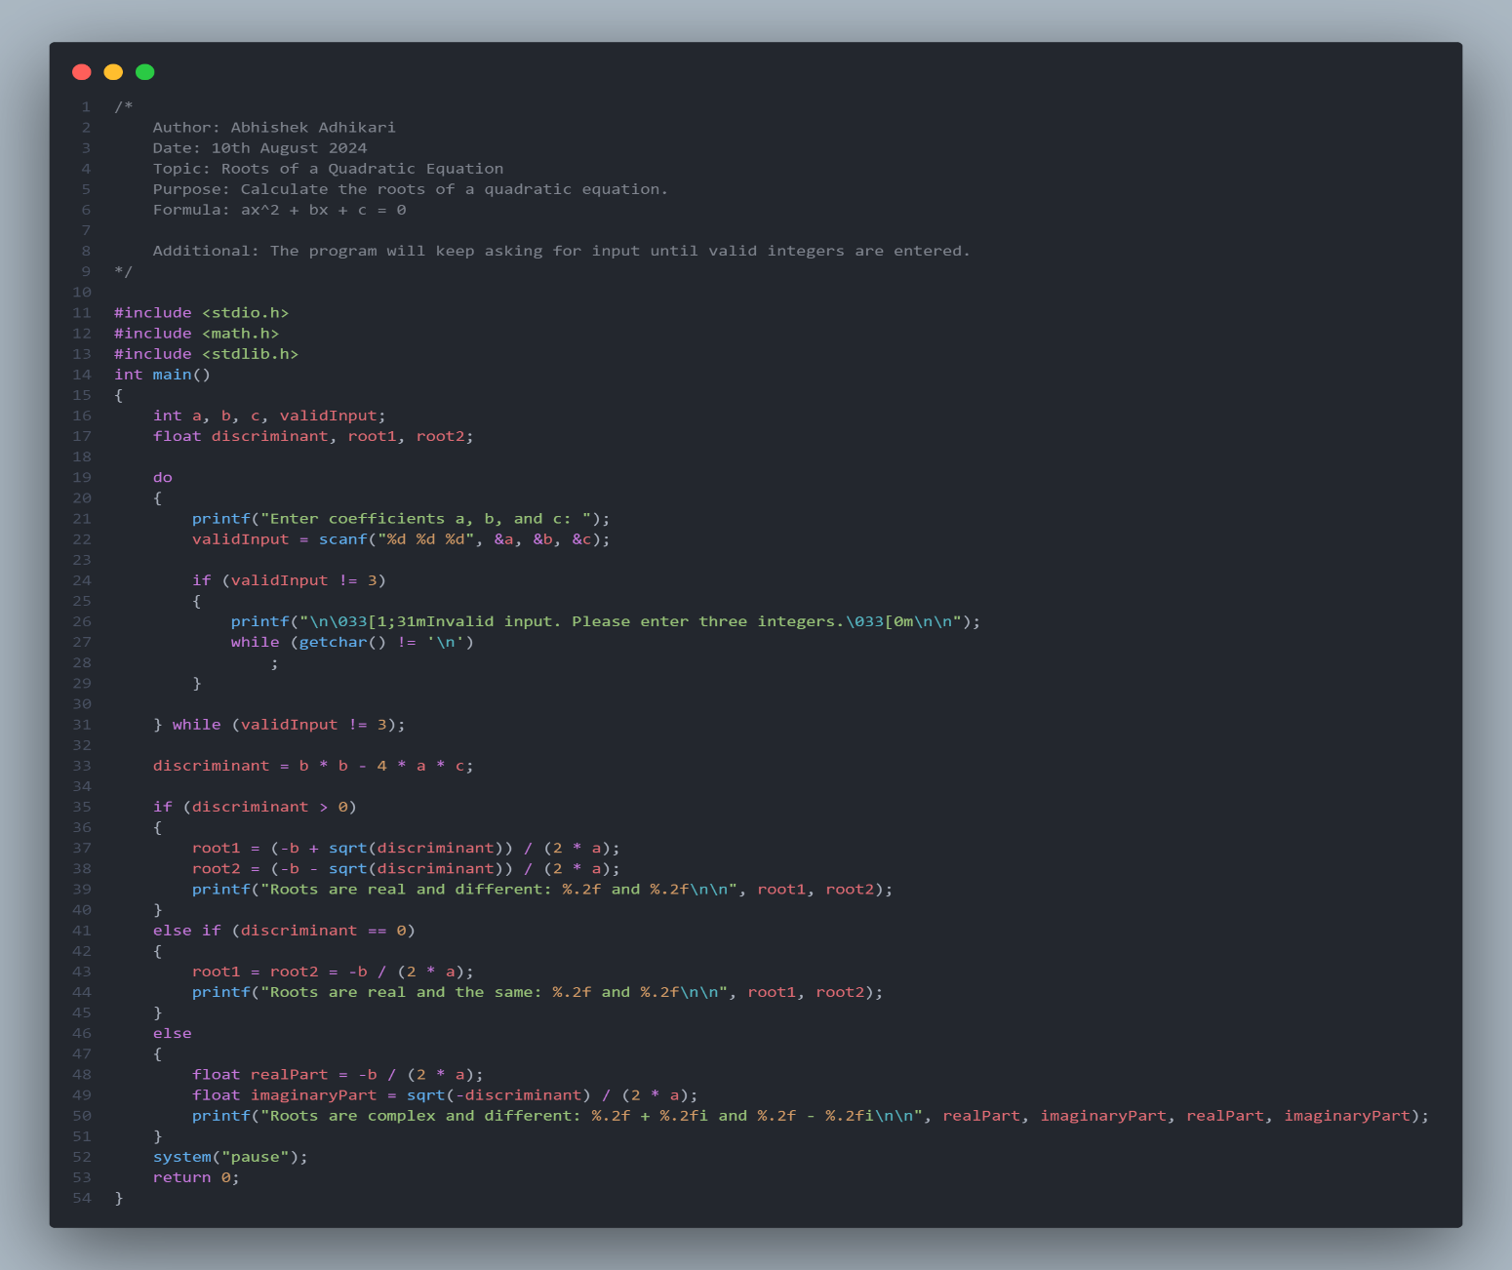

#### Output:

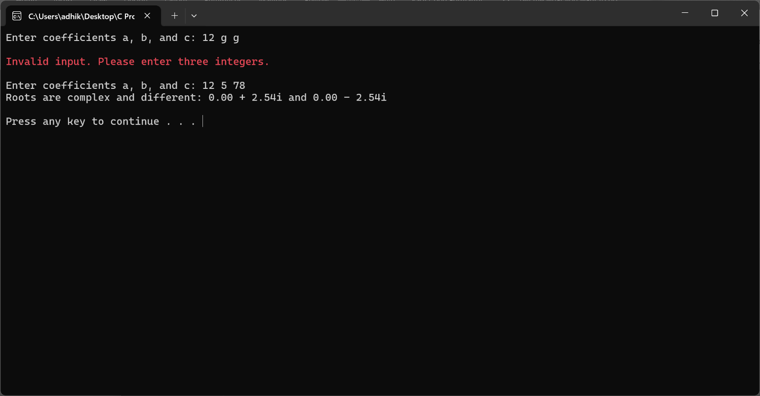

### 2.9 Calculate Total, Percentage, and Division

#### Explanation:

* The program calculates total marks, percentage, and division based on user input.

#### Code:

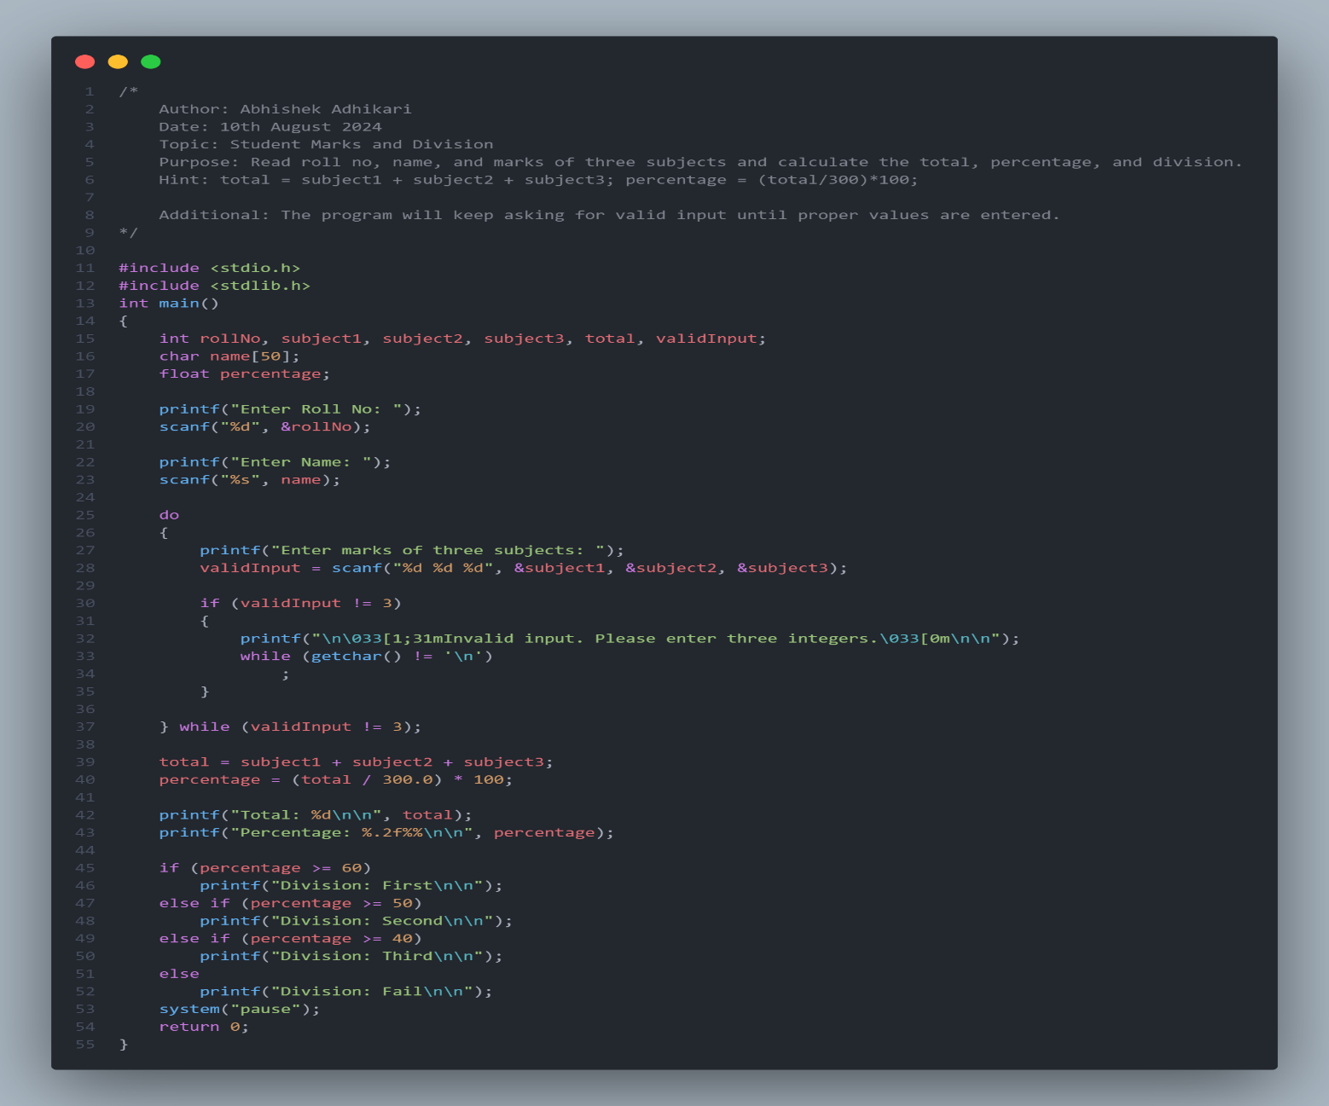

#### Output:

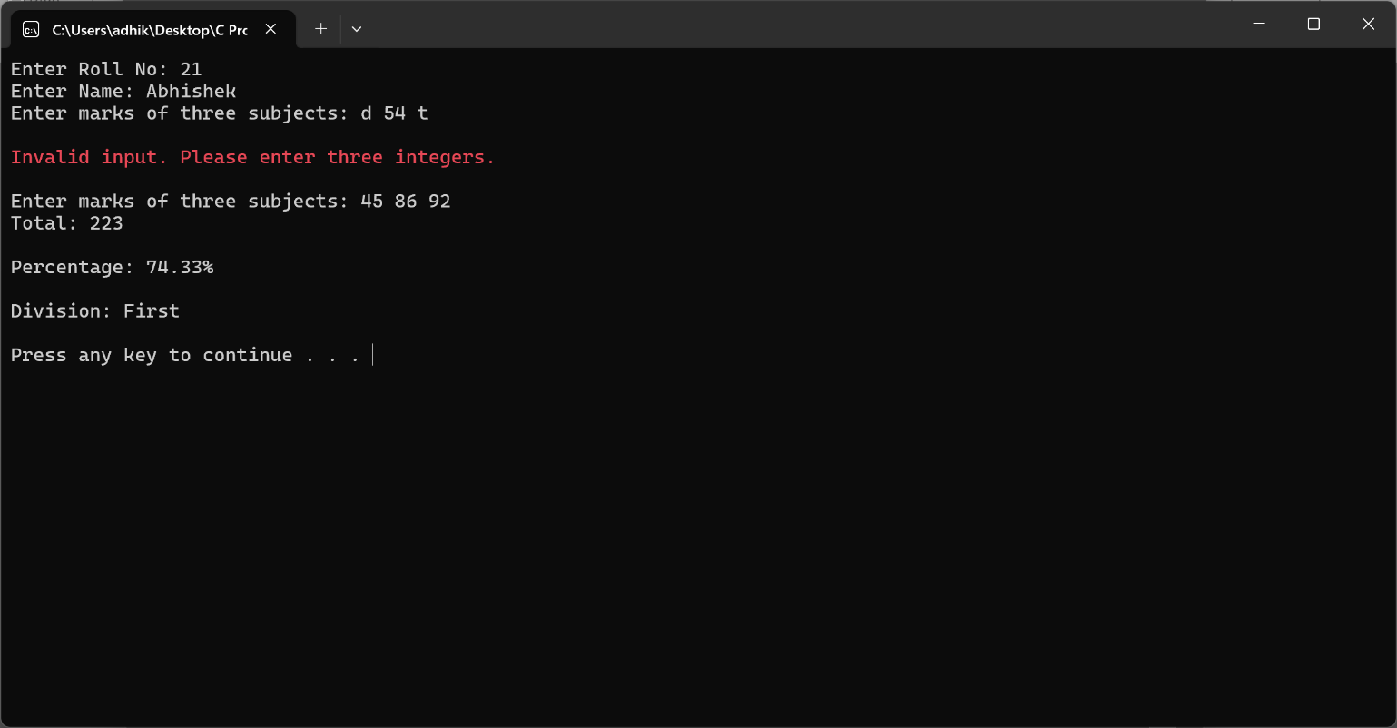

### 2.10 Temperature Categorization

#### Explanation:

* The program evaluates the temperature and prints a suitable weather message.

#### Code:

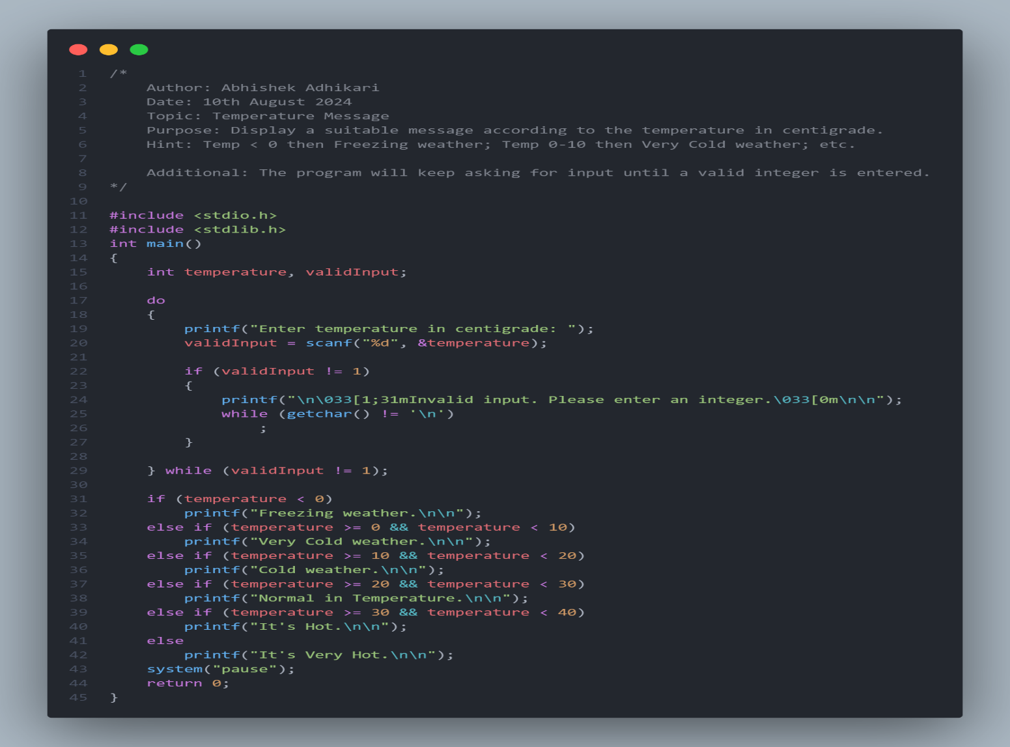

#### Output:

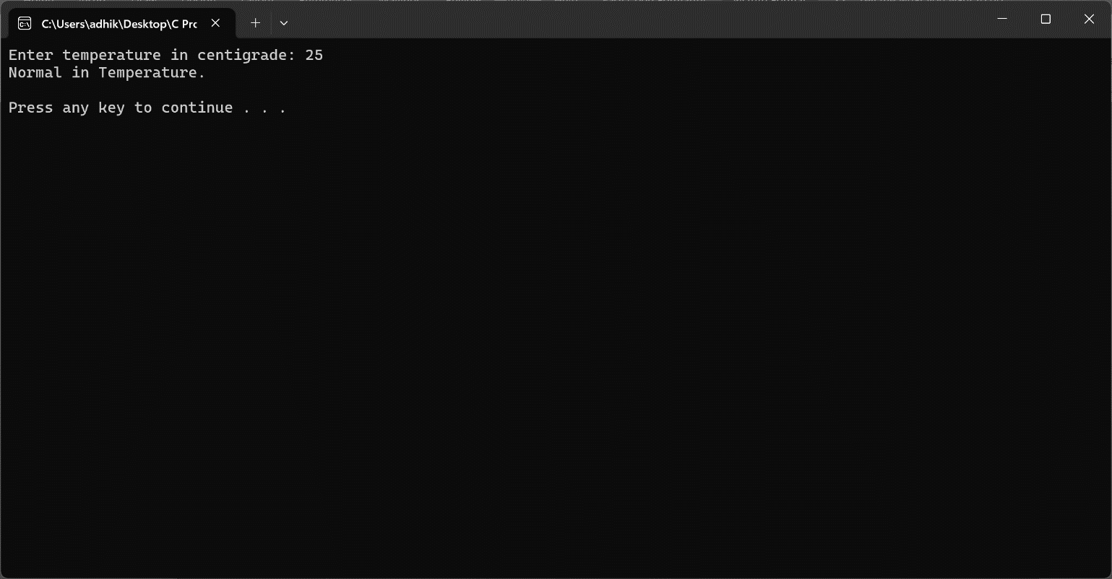

### 2.11 Check Triangle Type

#### Explanation:

* The program categorizes the triangle based on its side lengths.

#### Code:

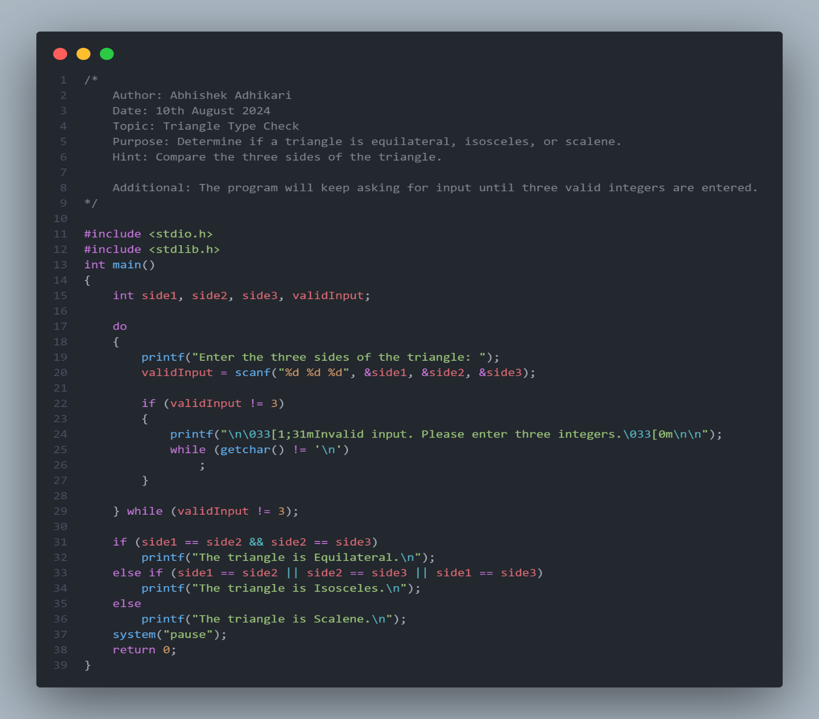

#### Output:

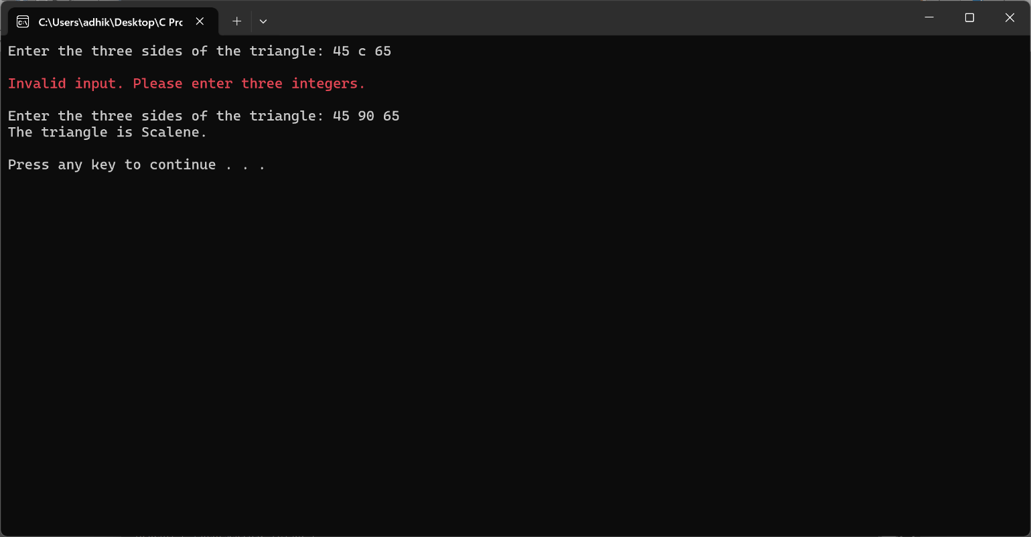

### 2.12 Check if a Triangle Can be Formed

#### Explanation:

* The program checks if the sum of the three angles equals 180 degrees to validate the triangle.

#### Code:

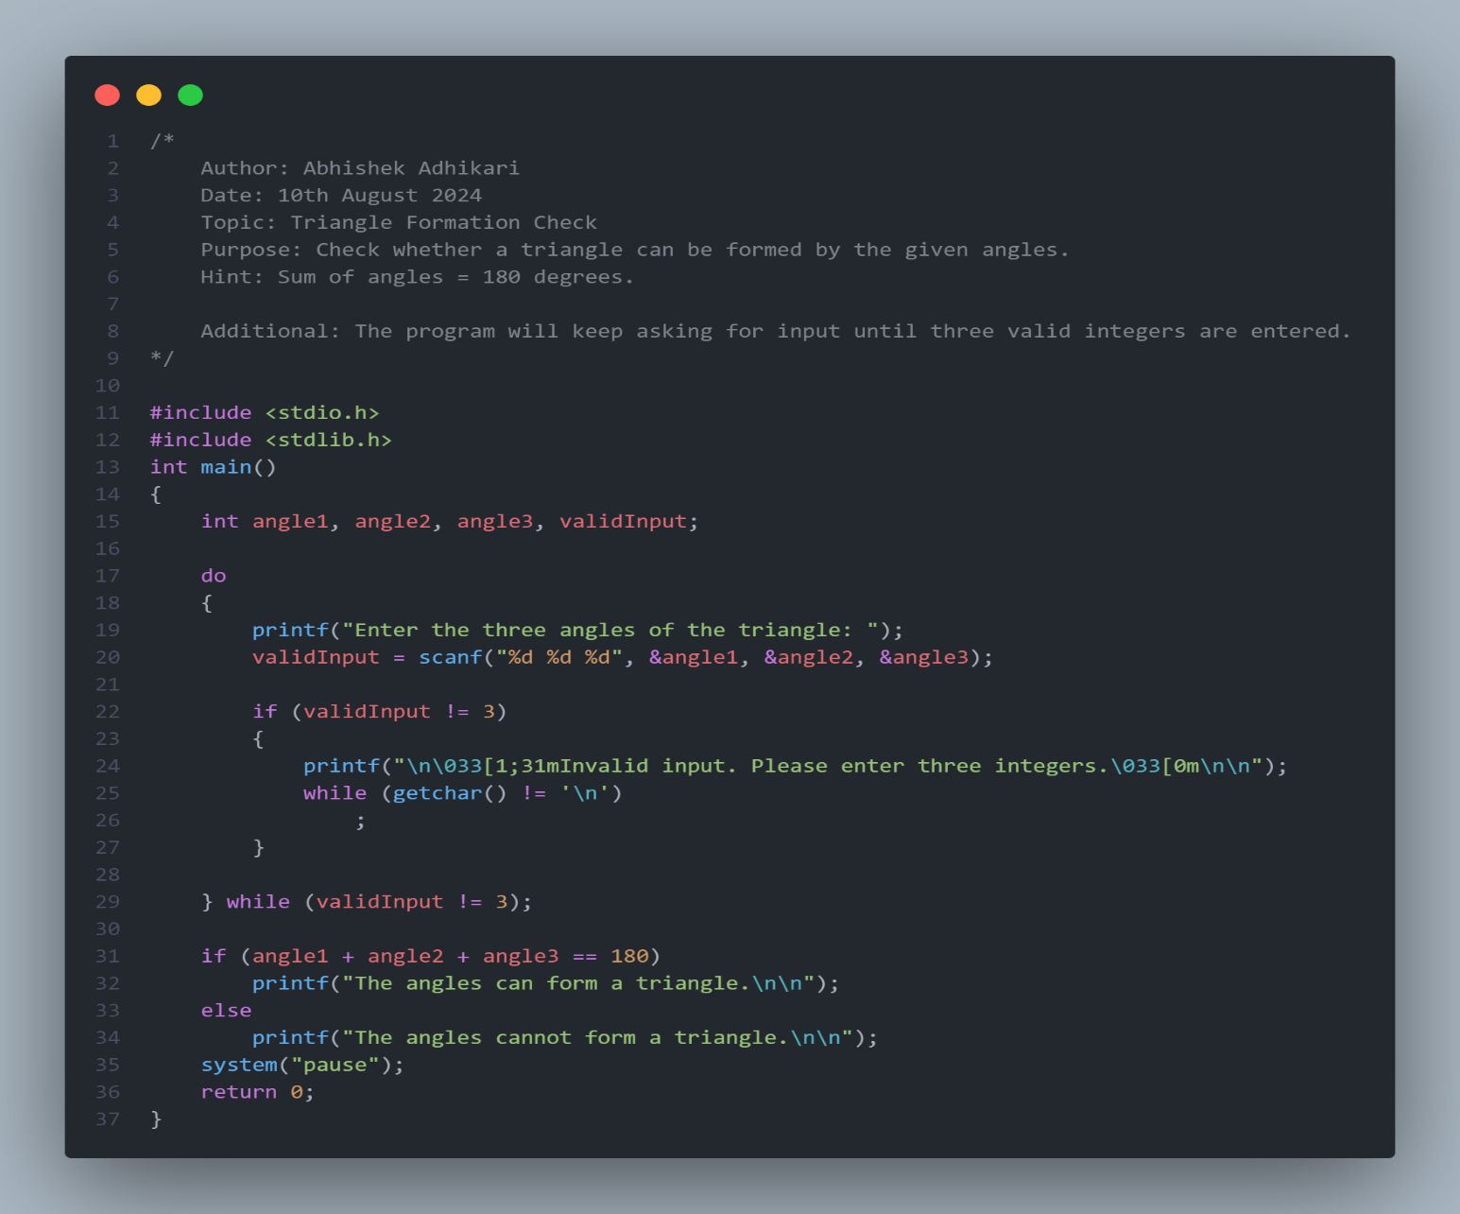

#### Output:

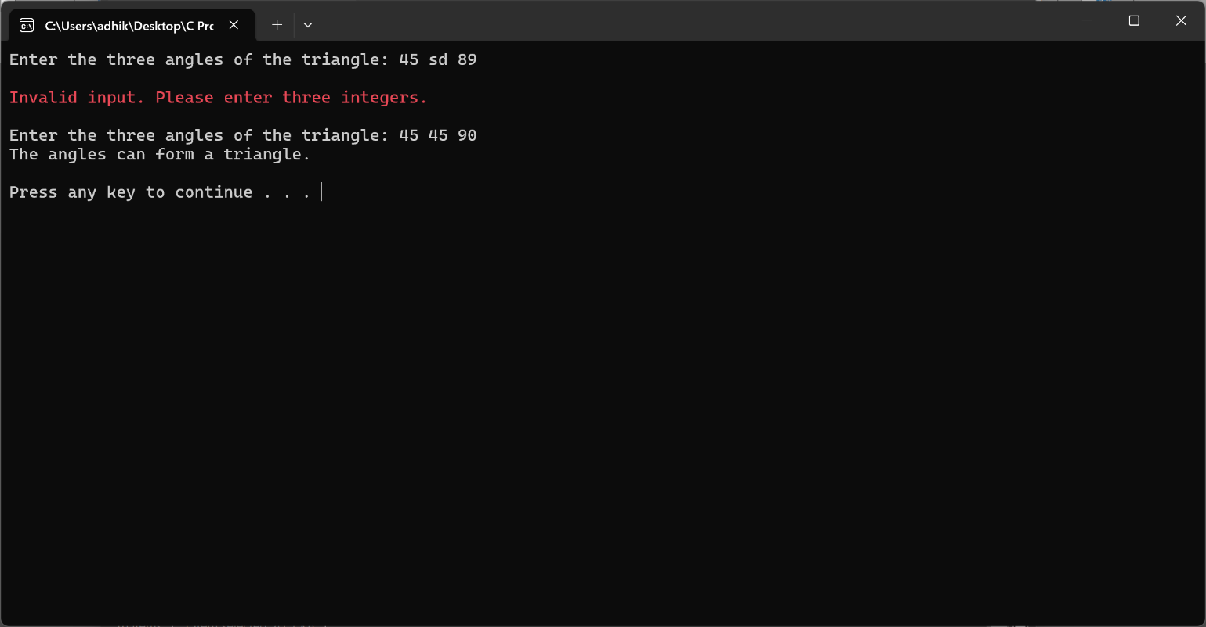

### 2.13 Check if a Character is an Alphabet, Digit, or Special Character

#### Explanation:

* The program uses standard library functions to classify the character.

#### Code:

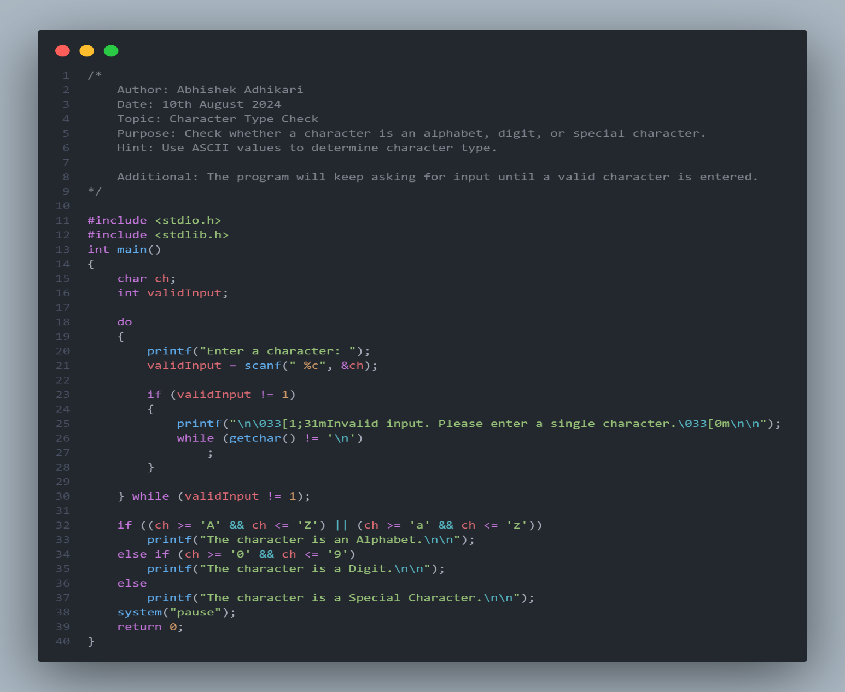

#### Output:

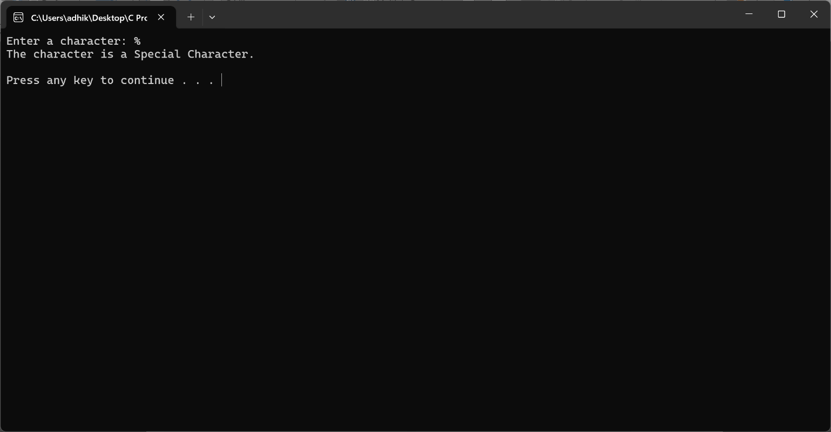

### 2.14 Check if an Alphabet is a Vowel or Consonant

#### Explanation:

* The program determines if the alphabet is a vowel or consonant.

#### Code:

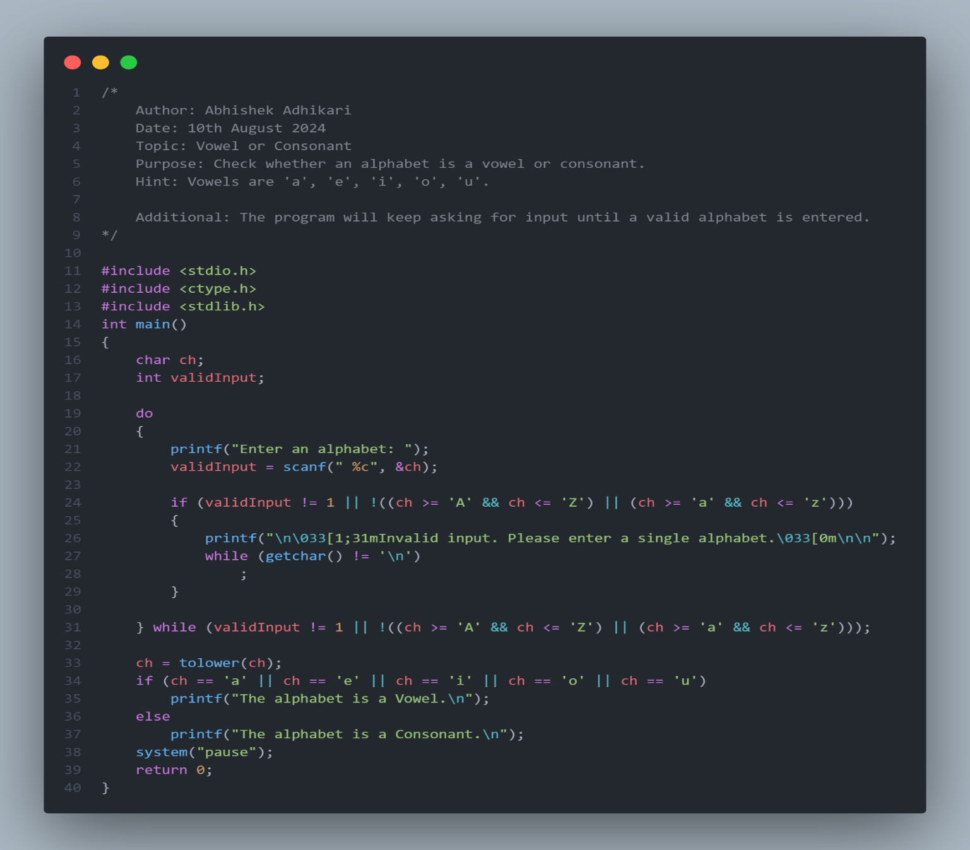

#### Output:

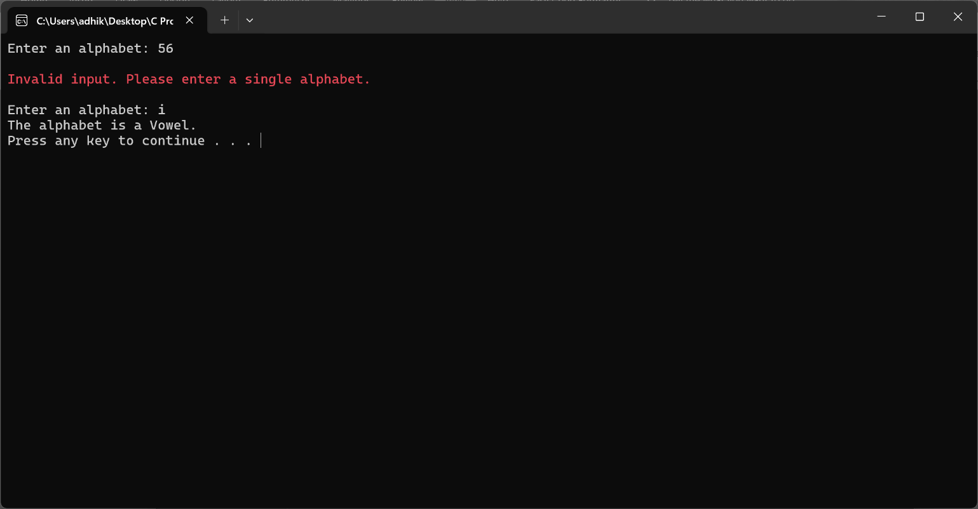

### 2.15 Check Character Type (Uppercase, Lowercase, Digit, Special Symbol)

#### Explanation:

* The program classifies the character based on its type.

#### Code:

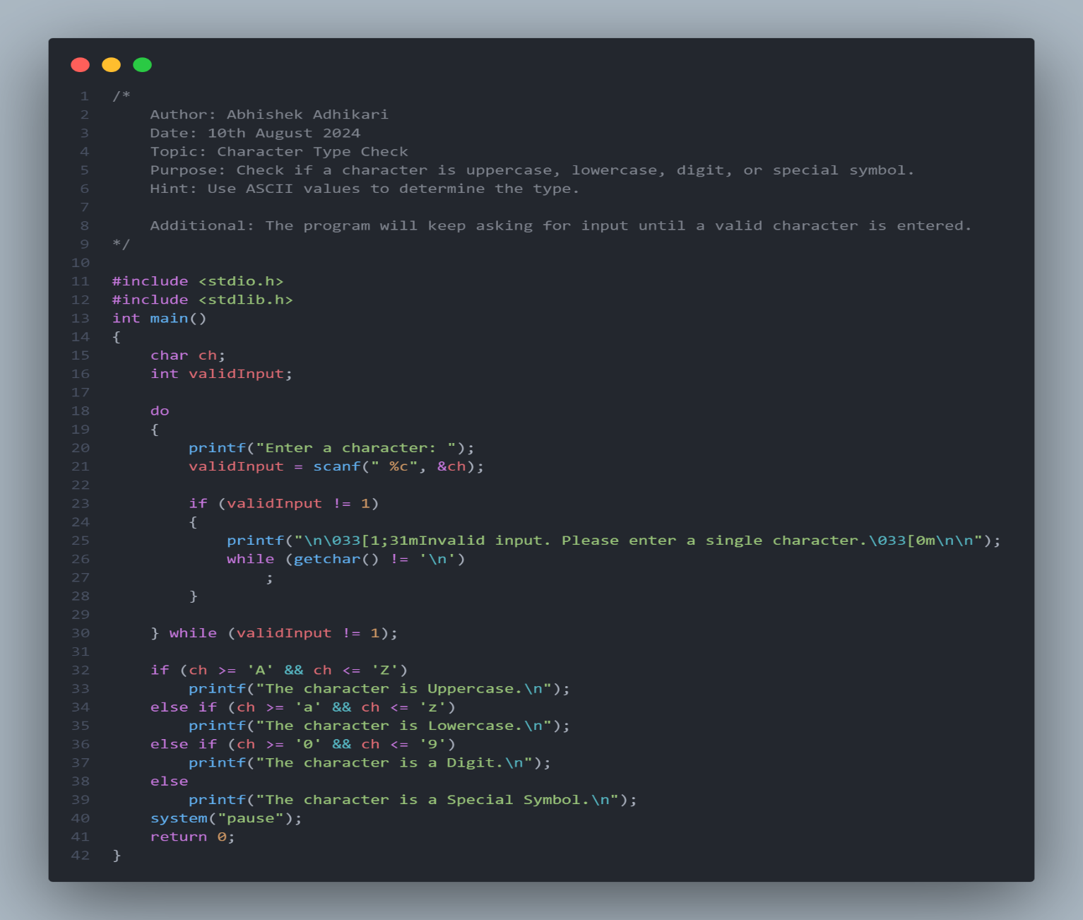

#### Output:

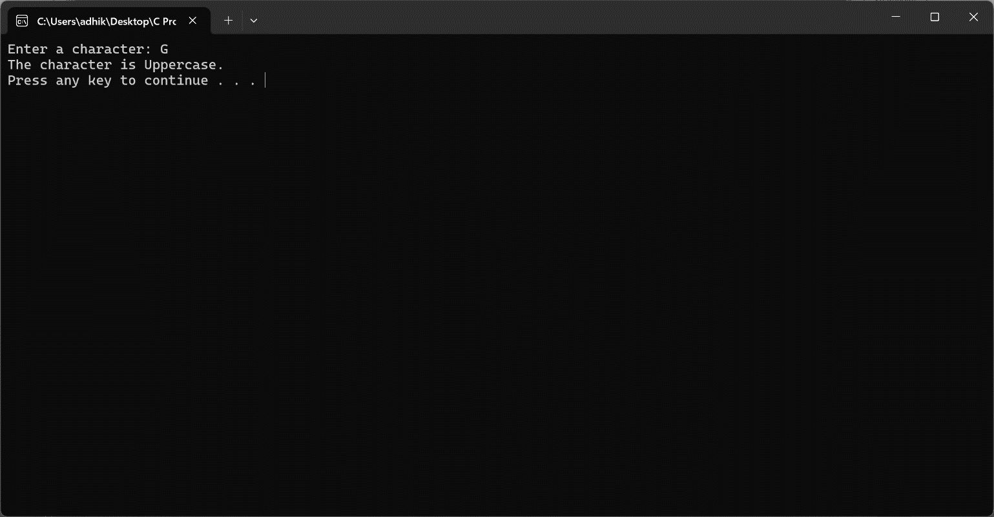

## Conclusion

This document provides a detailed overview of the various C programming exercises, including explanations, code, and instructions for each program. Please refer to the screenshots provided to see the programs in action.

## References

**C Programming Language - K&R**

* *Authors:* Brian W. Kernighan and Dennis M. Ritchie
* *Description:* A seminal book on C programming, providing foundational knowledge and in-depth explanations of C syntax and features.
* *Link:* [The C Programming Language](https://www.amazon.com/C-Programming-Language-Brian-Kernighan/dp/0131103628)

**GNU C Library Documentation**

* *Description:* Official documentation for the GNU C Library, providing detailed information on C standard library functions and their usage.
* *Link:* GNU C Library Documentation

**GeeksforGeeks: C Programming Language**

* *Description:* A comprehensive collection of articles, tutorials, and coding examples for learning C programming concepts and solving problems.
* *Link:* GeeksforGeeks C Programming